DOCUMENTATION

ASSIGNMENT 4

STUDENT NAME: Veres Noémi
GROUP: 30423

CONTENTS

1. Objective 3
2. Problem analysis, modeling, scenarios, use cases 3
3. Design 4
4. Implementation 6
5. Results 7
6. Conclusion 7
7. Bibliography 7

Objective
The main objective of Assignment 4 is to design and implement a Food delivery system for a catering company. The system should have three types of users that log in using a username and a password: administrator, regular employee, and client. The administrator can import the initial set of products for the menu and then manage these items. He can also generate reports about the performed orders so far based on different criteria. The employee will get notified whenever a new order is placed. The client can filter the products from the menu and order products from the company’s menu.
The sub-objectives are the following:
- Analyze the problem and identify requirements
- Design the food delivery system
- Implement the food delivery system
- Test the food delivery system

For this assignment, we had several methods to implement. The problem analysis will be detailed in the next chapter: 2. Problem analysis, modeling, scenarios, use cases. The design of the food delivery system had to be made by specific design patterns. I used the Design by Contract Technique for providing a detailed specification based on the requirements and also the Observer Design Pattern, which is explained in the 3. chapter. The implementation is detailed in the 4. chapter, where all the classes are presented and their main methods. Whenever writing a program, testing is an essential part of it, however, we must remember that “The absence of evidence is not necessarily evidence of absence”. Even though all the test cases are running correctly, this does not mean that our program is free of errors as we cannot cover all the special cases. We can only minimize the chance of running into problems. Further information about testing the food delivery system can be found in the 5. chapter.

Problem analysis, modeling, scenarios, use cases
The functional requirements of this problem are:
- The application should allow users to register
- The application should allow users to log in
- The application should allow the admin to import the base products from an excel file
- The application should allow the admin to manage the product, i.e., add, delete, edit
- The application should allow the admin to create composite products from already existing products
- The application should allow the admin to generate reports on different criteria, like date or price
- The application should allow a client to filter the products from the menu (available filters are: keyword, minimum rating, sodium, protein, fats, maximum calories or maximum price)
- The application should allow a client to create an order which can be composed from several items from the menu
- The application should allow an employee to get notified when a new order is made and he should see which items should be prepared in which quantity

Non-Functional requirements might include:
- The Food delivery system should be intuitive and easy to use by the user
- The Food delivery system should be reliable, the result should be precise, for the user to trust our application
- The application should use authentication to restrict the access of clients and regular employees to the administrator’s functionalities
- The Food delivery system should deal with incorrect user inputs and display messages that can help the user find the issue (for example: Wrong password! Please make sure that you insert the correct password. or Unsuccessful log-in. Please make sure that you are registered.)

Now the use cases will be presented.
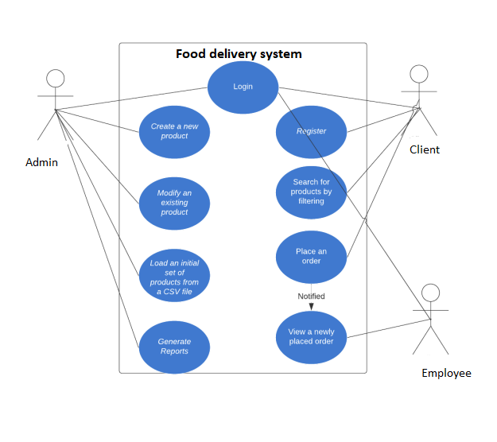

Use Case: login
Primary Actor: user
Main Success Scenario:
1. The user enters a username and password
2. The user presses the “Log in” button
3. The user gets logged-in
Alternative Sequence: Incorrect password
The user inserts an incorrect password
The application displays an error message and requests the user to make sure that the password is correct
The scenario returns to step 1

Use Case: register
Primary Actor: client
Main Success Scenario:
1. The client clicks on the “Register now” button
2. The client enters a username and the chosen password 2 times
3. The client presses the “Register” button
4. The client will be registered
Alternative Sequence: The 2 passwords do not match
The client inserts 2 passwords which do not match
The application displays an error message and requests the user to insert the same password
The scenario returns to step 1

Use Case: generate reports
Primary Actor: admin
Main Success Scenario:
1. The admin should log in first
2. The admin should insert the data based on which he wants to create the reports
3. The admin presses the corresponding “Generate report” button

Use Case: place an order
Primary Actor: client
Main Success Scenario:
- The client should be log in first.
- The client selects an item from the menu.
- The client specifies the quantity from that item.
- The client adds the item with the quantity to the order by pressing the button “Add to order”.
- The scenario returns to step 2 as long as the user wants more products.
- The client presses on the “Place order” button
- An order is placed by the client, employee gets notified.

Use Case: view an order
Primary Actor: employee
Main Success Scenario:
- An order should be placed first by the client
- The employee should then see the order

Modifying products is similar to the use cases presented in the third Assignment.

Design
For this assignment, I have 6 packages inside main.java: bll, dal, gui, model, start, and utils. I have used a specific architectural pattern, the so-called Conceptual Architecture pattern. In the sub-packages, I grouped the classes which are correlated. For this, a model package is needed, which contains the classes mapped to the items, users and orders. The Presentation Layer contains the classes related to the graphical user interface, like View and Controller. It communicates with the business logic and model. The Business Layer classes are the ones who encapsulate the application logic and the Data Access Layer contains the classes for serialization and writing to files. The start package contains only one class, which has the main method for starting the application. Finally, a utils package was added, which contains the TableFactory class needed for generating the header of a table by extracting through reflection the object properties and then populating the table with the values of the elements from the given list.

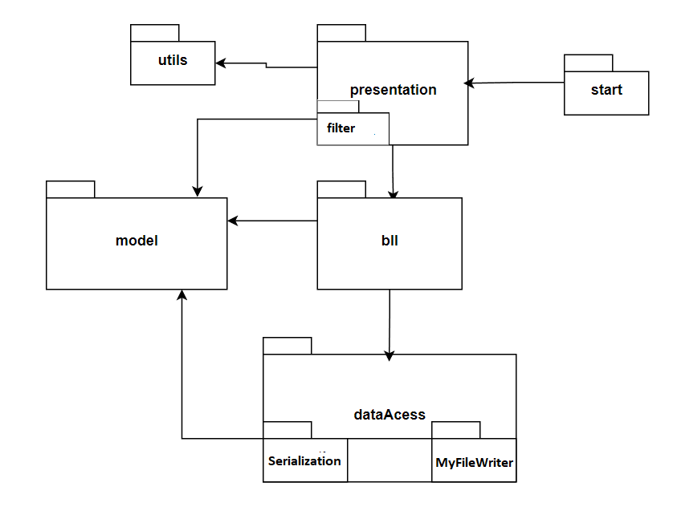
The following UML diagram shows us the dependencies between some of the classes and the main methods of each class:

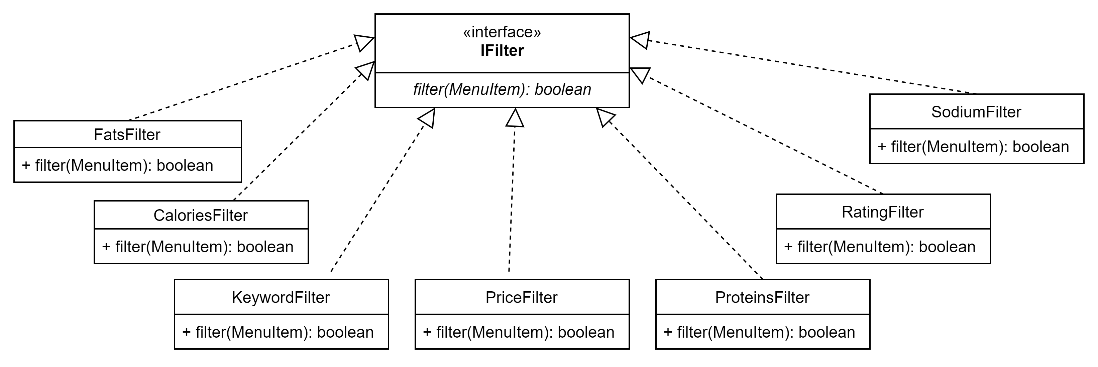
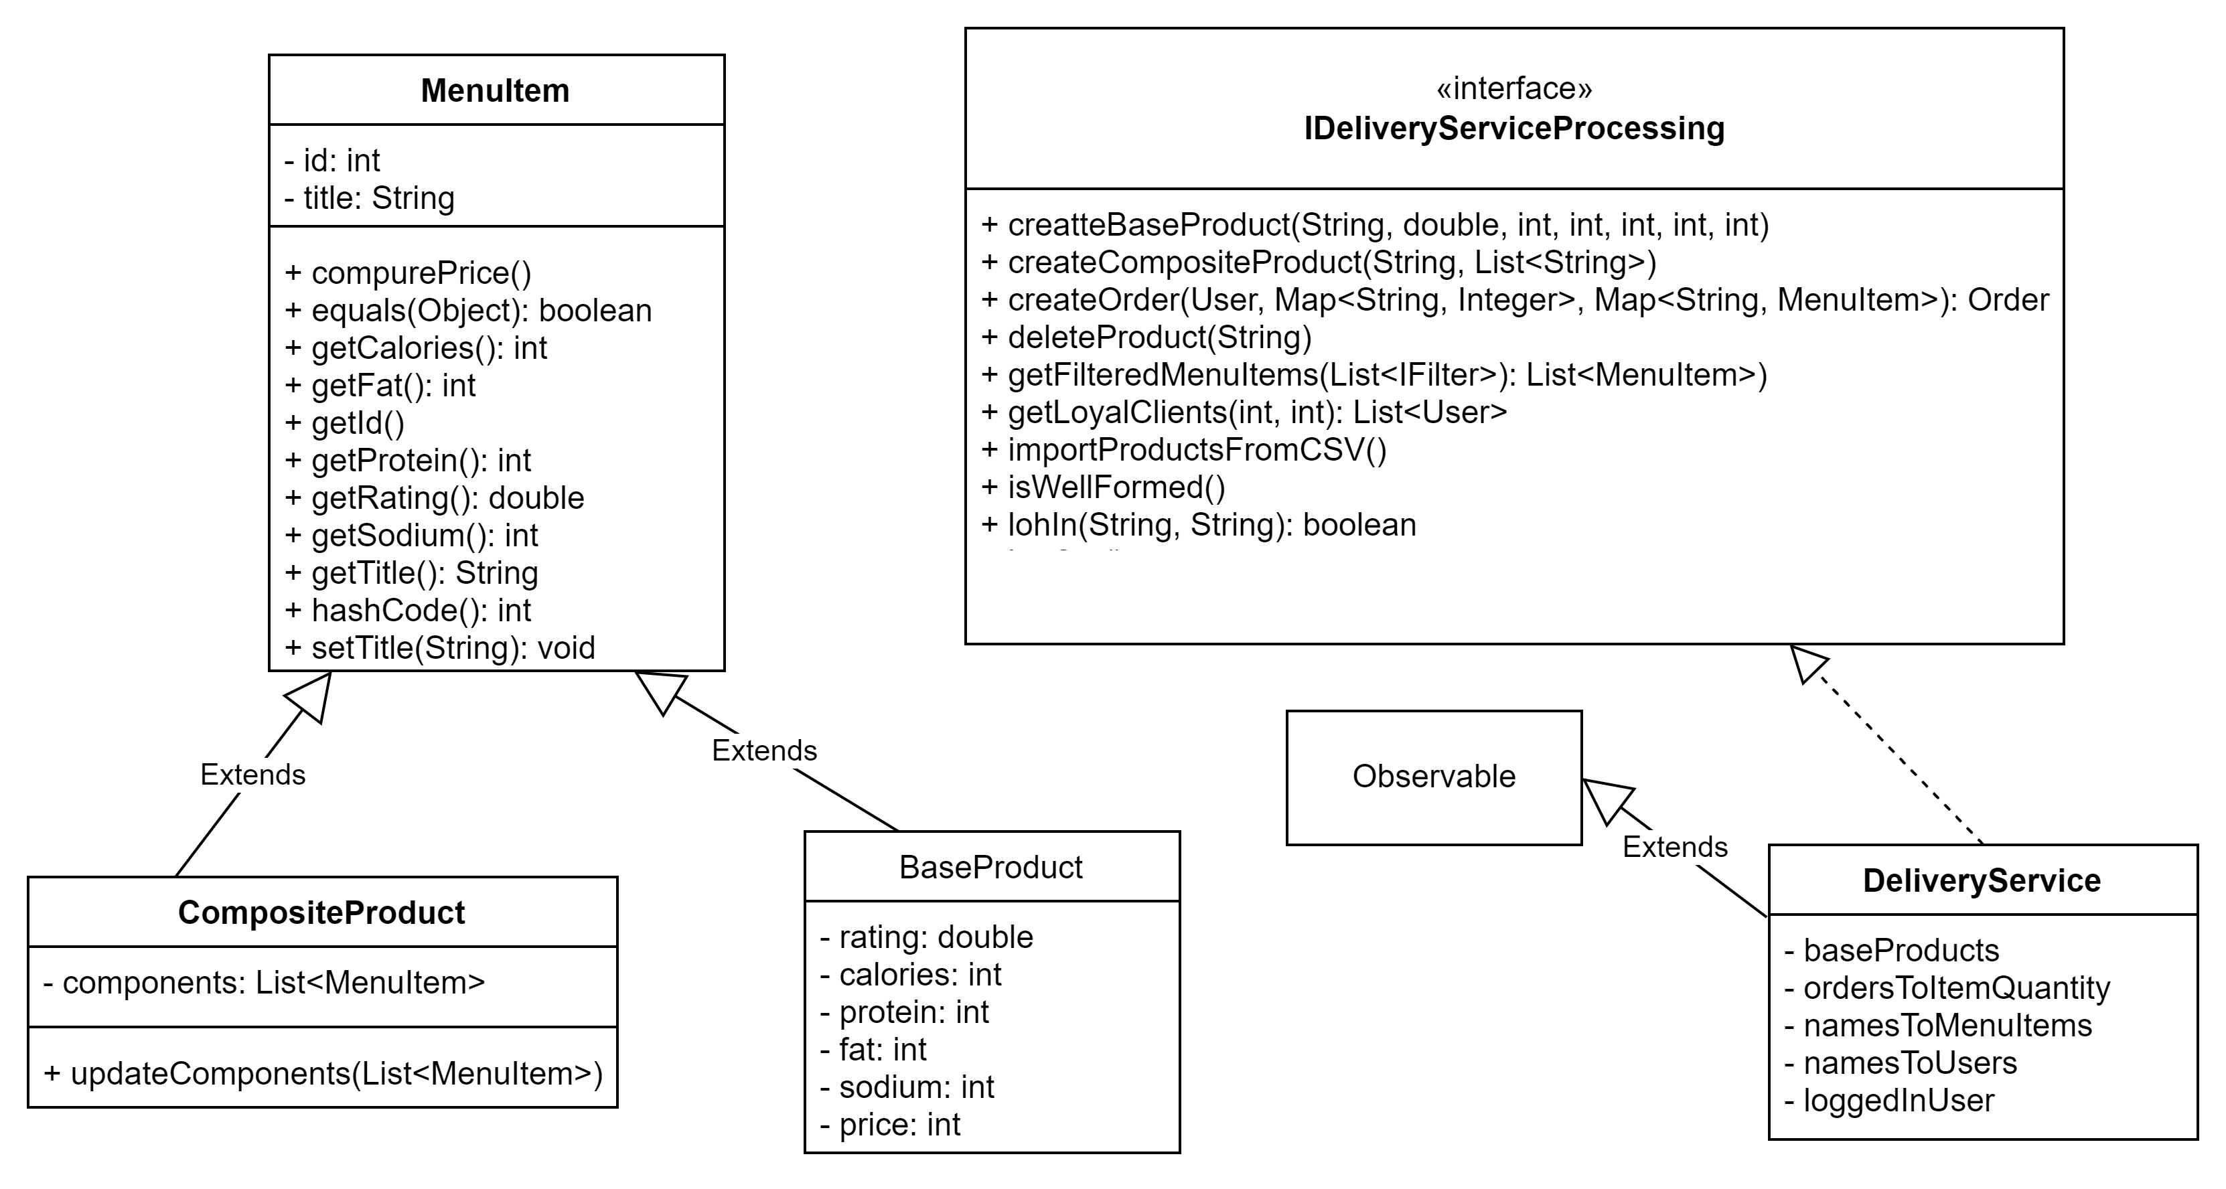

Implementation
Let us take each class separately and describe their main fields and methods.
The Model package contains 7 classes: BaseProduct, CompositeProduct, MenuItem, MenuItemToNoOfOrders, Order, TypeOfUser, User. Each one has its own fields, getters and setters. The BaseProduct class represents a base product which can further compose other products. It extends the MenuItem class, which is abstract. In the MenuItem class we had to override the equals() and hashcode() method, in order to be able to put them in a map accordingly. The composite product class also extends the MenuItem class and this one has as an attribute a list of MenuItem components. By this, we are able to compose complex products, like a menu. The different menu items can be combined to obtain a whole new menu item. For example, a daily menu may consist of a soup, a second course and a dessert. The TypeOfUser class is an enumeration, with the elements: ADMIN, EMPLOYEE, CLIENT, which indeed represent the types of user who can use our application, having different levels of access. A User has the id, username, password and typeOfUser private fields, representing a registered user of our application. The Order class was also necessary to implement. Because the clients are the ones who can place the orders, one of its private fields is the clientId, the other ones being orderId and time.
The View class is using Java Swing, to create a user-friendly graphical interface. We have many private fields here, of type JPanel, JLabel, JTextField, and JButton – for activating some operations. The constructor receives a String, which will be the name of our application as all frames must have a name. One other method is prepareGui() which will prepare the main window of our application. We also have three other windows: for the client, admin and employee. In these classes I also used JTables which required also some getters to access them. I placed labels in the frames, to inform the user what they have to do.
In the Controller class, we make the connections between the View and Model. Apart from the constructor, we have an actionPerformed(ActionEvent e) method, which gets some commands as a String. Using if statements, we decide what to do when certain buttons are pressed. It must be also noted, that this class implements the Observer interface, so it overrides the update method in order to notify the employee that a new order was placed. For this, the constructor of the controller with the clientWindow argument adds to the observer itself and the DeliveryService class has to extend Observable. Although the Observer and Observable classes are deprecated, they worked perfectlt for our purpose.
In the gui package, I have two other classes: ReadingARow and RowListener which help us select a certain product from the menu table. After that, an order can be made or a new composite product can be created.
The bll package contains another package filter and 2 other classes: an interface: IDeliveryServiceProcessing and a class which implements it: DeliveryService. This one contains the implementation of the most important mehods of the application. For example, the createBaseProduct() method, which creates a new base product by adding it to the menu, having the given attributes.
void createBaseProduct(String title, double rating, int calories, int protein, int fat, int sodium, int price);

Other methods for manipulating the products are also implemented here, as well as methods for generating the reports.
void modifyBaseProduct(String title, double newRating, int newCalories, int newProteinsAmount, int newFatAmount, int newSodiumAmount, int newPrice);

void deleteProduct(String title);

void importProductsFromCSV();

List<Order> getOrdersInTimeInterval(LocalTime startTime, LocalTime endTime);

I also implemented some methods for managing the users, like:
boolean logIn(String userName, String password);

User registerUser(String userName, String password, TypeOfUser type);
The createOrder method was also necessary, which will call in its turn the createBill method from the MyFileWriter class, to generate a bill.
Order createOrder(User client, Map<String, Integer> orderedItemNamesToQuantity, Map<String, MenuItem> menuItemNamesToMenuItems) throws IOException;
The bill will be a txt file, containg information about the order:
Client: client
Lamb Köfte with Tarator Sauce - quantity: 4 - unit price: 88
Spicy Pickled Shallots - quantity: 2 - unit price: 78
Total price: 508
The isWellFormed() method shows whether an object is in valis state. For example, each order has to contain at least 1 element.
ordersToItemQuantity.values().stream()
.flatMap(menuItemToQuantityMap -> menuItemToQuantityMap.entrySet().stream())
.noneMatch(element -> (element.getKey() == null || element.getValue() == null));

The IFilter interface contains one abstract method: filter, which will filter the products from the menu. The CaloriesFilter, FatsFilter, KeywordFilter, PriceFilter, ProteinsFilter, RatingFilter and SodiumFilter classes implement this method, filtering the products based on different criteria.
public interface IFilter {
boolean filter(MenuItem menuItem);
}
The TableFactory class uses reflection techniques for the following methods: retrieveColumns(E object) and retrieveData(ArrayList<E> objects, int length). Finally the createTable() method creates a table with the columns and data obtained with the previous methods.

Results
We have a friendly interface for the client. In this window, the client can apply different filters on the products and also place an order.
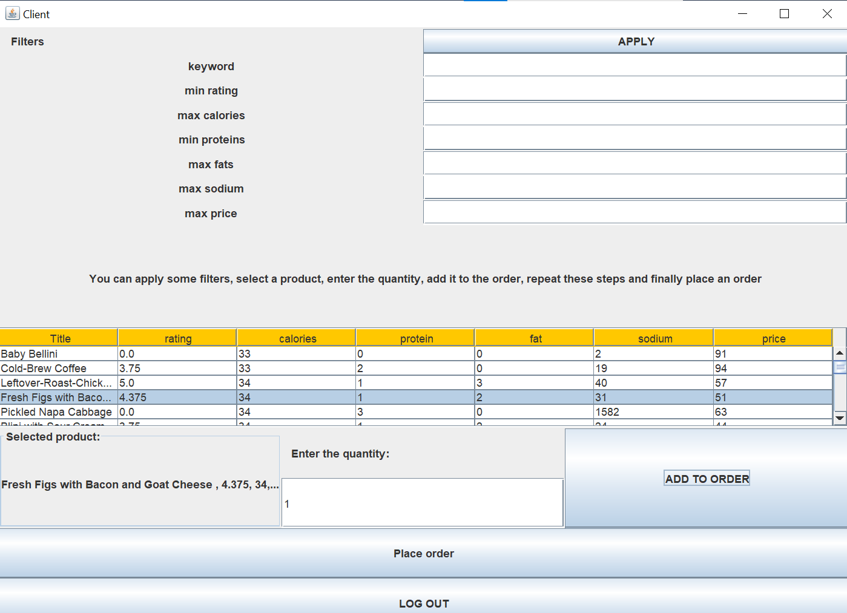
A product should be selected first and then a quantity should be specified. Then the product can be added to the order. This step can be taken again, until the client selected all the products he wanted. When he presses the “Place order” button, the following message will appear:

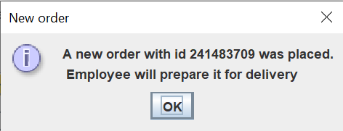
After we press “OK”, an employee window will appear, so that the employee will see the order he has to prepare.
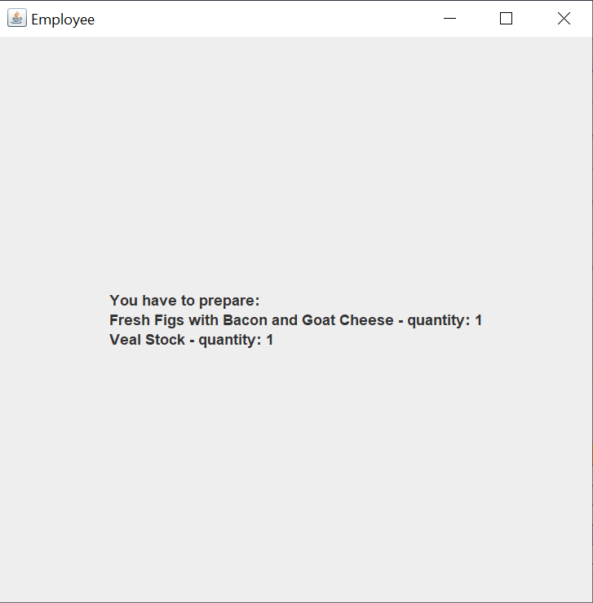

Conclusion
There were many concepts and also practical things that I have learned from this assignment. I learned how to divide the whole system into smaller parts, using a specific architectural pattern, the Conceptual Architecture in this case. The main parts of this architecture are the graphical user interface (GUI) – the presentation layer, business logic, data models and data access.
For this assignment, I had to learn to recursively create new products out of existing ones. Using Javadoc comments was another essential part, in addition, I learned to use the Design by Contract Technique, for providing detailed specifications based on the requirements. I had to use 3 types of assertions: precondition, postcondition and invariant. Serializing data was another key aspect, as well as using the Observer Design Pattern for informing the employee when an order was made.
All in all, this assignment helped me divide a complex program into small subproblems, efficiently solve them and then recombine them to obtain the final application with all of its functionalities.
The application can be further developed, for example, the user interface could be much more friendly by using different colors. Not all of user input cases are validated, so other error messages should also be displayed. In order to be more clear and readable, the controller class could be divided into other classes, the main controller, from where we could select on which window we want to make modifications. The other 3 classes could be ClientController, which would react to the buttons from the ClientWindow, the ProductController for the ProductWindow and the OrderController for the OrderWindow. In the current moment, any user can register as an admin, which might create big problems as any user could modify the products. We must somehow restrict the registration of new users, so they can register only as their type, maybe with a password for the admin or the client.

Bibliography

The presentation provided on the course website was also useful, containing some suggestions about the design and theoretical background of Java Database Connectivity: FUNDAMENTAL PROGRAMMING TECHNIQUES (dsrl.eu). For the streams, I used the following website: Processing Data with Java SE 8 Streams, Part 1 (oracle.com) For selecting a certain row in the clients or products table, I consulted the following website: how to get the values from selected row of JTable (Swing / AWT / SWT forum at Coderanch).

